**ST.XAVIER’S COLLEGE**

MAITIGHAR, KATHMANDU



**Computer Graphics**

Assignment #8

Submitted By:

Pratik Gautam

013BSCCSIT029

Submitted to:

|  |  |
| --- | --- |
| Er. Anil Shah  Lecturer  Department of Computer Science |  |

**Statement:**

**PERFORM TRANSFORMATION IN THE IMAGE BY REFLECTION.**

1. **REFLECTION:**

**Algorithm:**

1. Get the width and height of the source image
2. Get parameter for reflection axis (1 for x-axis, 2 for y-axis)
3. For each point i in width

For each point j in height

If parameter==1

The translated point (x’, y’) is given by

x' = i

y’ = - j

If parameter==2

The translated point (x’, y’) is given by

x' = - i

y’ = j

Plot the points (x’, y’) with the same color as source in destination

1. Stop

**Source Code:**

//---------------------------------------------------------------------------

#include <vcl\vcl.h>

#pragma hdrstop

#include "Unit1.h"

//---------------------------------------------------------------------------

#pragma resource "*.dfm"

TForm1 *Form1;

//---------------------------------------------------------------------------

__fastcall TForm1::TForm1(TComponent* Owner)

: TForm(Owner)

{

}

//---------------------------------------------------------------------------

void __fastcall TForm1::Button1Click(TObject *Sender)

{

int h,w,i,j,a,b,c,d;

int mx,my;

h=outPanel->Height;

w=outPanel->Width;

mx=w/2;

my=h/2;

for(i=0;i<=w;i++){

for(j=0;j<=h;j++){

a = -(i-mx)+mx;

b = j;

outPanel->Canvas->Pixels[a][b] = outPanel->Canvas->Pixels[i][j];

}

}

//Drawing Y axis

outPanel->Canvas->MoveTo((outPanel->Width)/2,0);

outPanel->Canvas->LineTo((outPanel->Width)/2,outPanel->Height);

//Drawing X axis

outPanel->Canvas->MoveTo(0,outPanel->Height/2);

outPanel->Canvas->LineTo(outPanel->Width,outPanel->Height/2);

}

//---------------------------------------------------------------------------

void __fastcall TForm1::Button2Click(TObject *Sender)

{

int h,w,i,j,a,b,c,d;

int mx,my;

h=outPanel->Height;

w=outPanel->Width;

mx=w/2;

my=h/2;

for(i=0;i<=w;i++){

for(j=0;j<=h;j++){

a = i;

b = -(j-my)+my;

outPanel->Canvas->Pixels[a][b] = outPanel->Canvas->Pixels[i][j];

}

}

//Drawing Y axis

outPanel->Canvas->MoveTo((outPanel->Width)/2,0);

outPanel->Canvas->LineTo((outPanel->Width)/2,outPanel->Height);

//Drawing X axis

outPanel->Canvas->MoveTo(0,outPanel->Height/2);

outPanel->Canvas->LineTo(outPanel->Width,outPanel->Height/2);

}

**//------------------------------**

**Output:**

Reflected along X axis

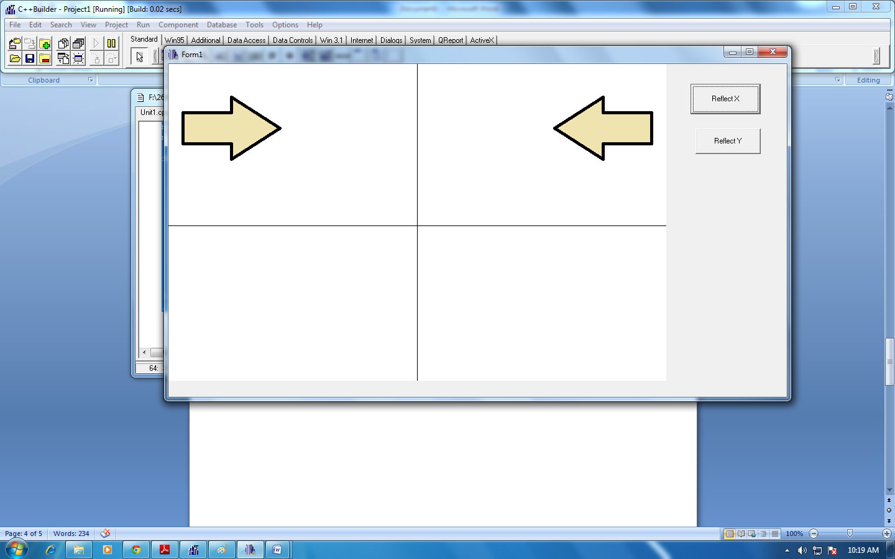

Reflected along Y axis

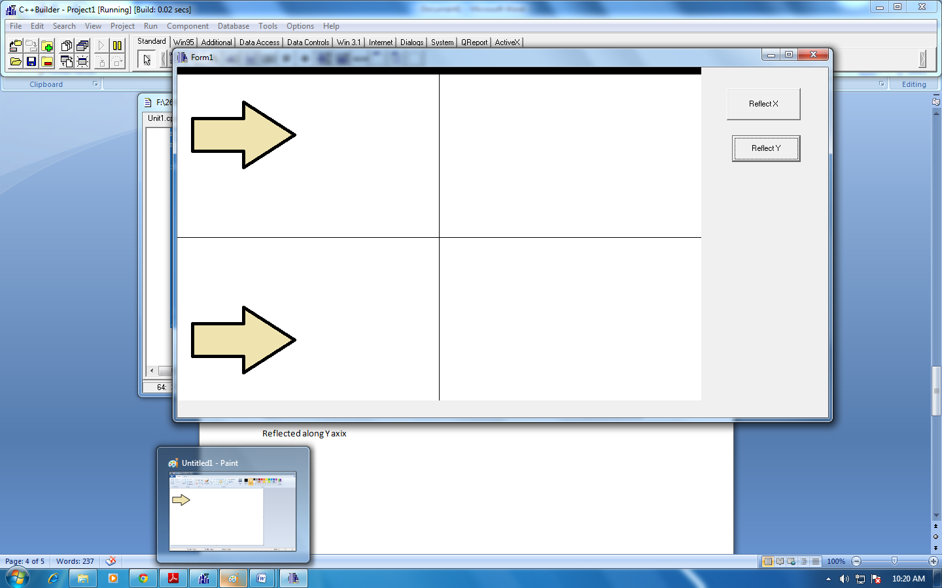

**Conclusion:**

Hence, reflection of object was performed using C++ Builder.